Geometry: Unit 11, Lesson 8
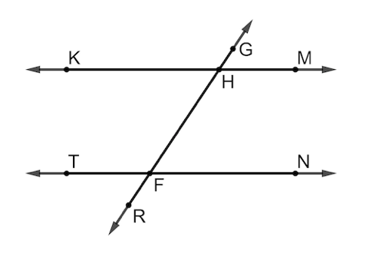
- Parallel lines $KM$ and $TN$ are shown, with transversal line $GR$. Why is $∠KHG≅∠TFH$?

Because the angles are corresponding angles

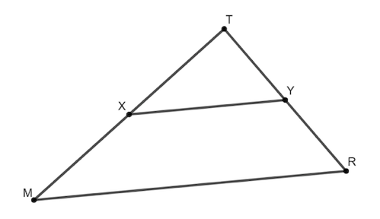

- Triangle $MTR$ is shown, where point $X$ is the midpoint of $\overline{MT}$, and point $Y$ is the midpoint of $\overline{TR}$. Is the statement $\frac{TY}{TR}=2$ true?

No

- What theorems can be used to prove triangle similarity?

SAS, AA, SSS Similarity Theorems

